Elevate - careers service

- Home
- YOUNG PEOPLE’S ZONE
- Elevate – careers service

Supporting you to make choices about your future
If you’re aged 16-18 years old (up to 25 years old for SEND and care experienced young people) we are here to help you and provide impartial advice to support you into employment, education or training.


How we can help

Exam result support
Helping you plan your next steps.

Exploring career ideas
Helping you make choices.

Choosing higher education
Your college, university and other higher education options.

Alternative training provisions
Find out what training is available.

Support for job hunting
Including interview skills and CV writing.

Apprenticeships and jobs
See our jobs board below.

Elevate summer careers fair, 10 July
Join our Elevate team for their annual summer careers fair, an opportunity for young people in Reading to meet local employers and explore career paths that interest them.
10 July from 11am-2pm
New Meaning, Portman Rd, RG30 1EA
To book a place, please call 0118 937 3766 or email the team at elevate@brighterfuturesforchildren.org.



Career information and advice sessions
The Elevate team is based at Reed recruitment agency’s office at 66-68, St Mary’s Butts, Reading, RG1 2LG. Appointments are offered on Tuesdays and Thursdays. Appointments are also held in Reading College and at the Civic Offices. Get advice on:
- exploring career ideas and making choices
- choosing options at age 16 and 18
- finding a learning or training course
- search and apply for jobs or apprenticeships
- support with transition to further education
- developing CV and improving interview skills
You will need to make an appointment so drop them a line on 0118 937 3766 or email them at elevate@brighterfuturesforchildren.org.
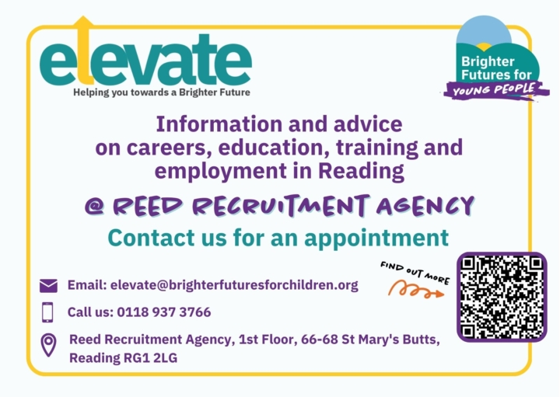
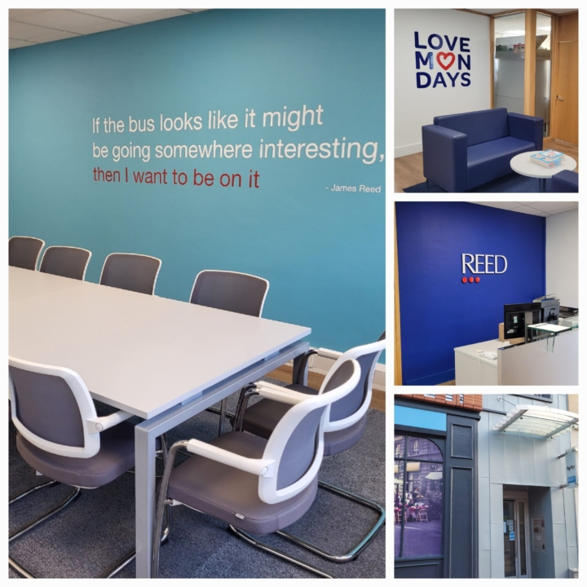

The latest apprenticeship and job vacancies foryoung people
Check our jobs board for the latest opportunities in Reading, including apprenticeships. If you want to find out more about current roles or other local opportunities email elevate@brighterfuturesforchildren.org or phone 0118 937 3766.


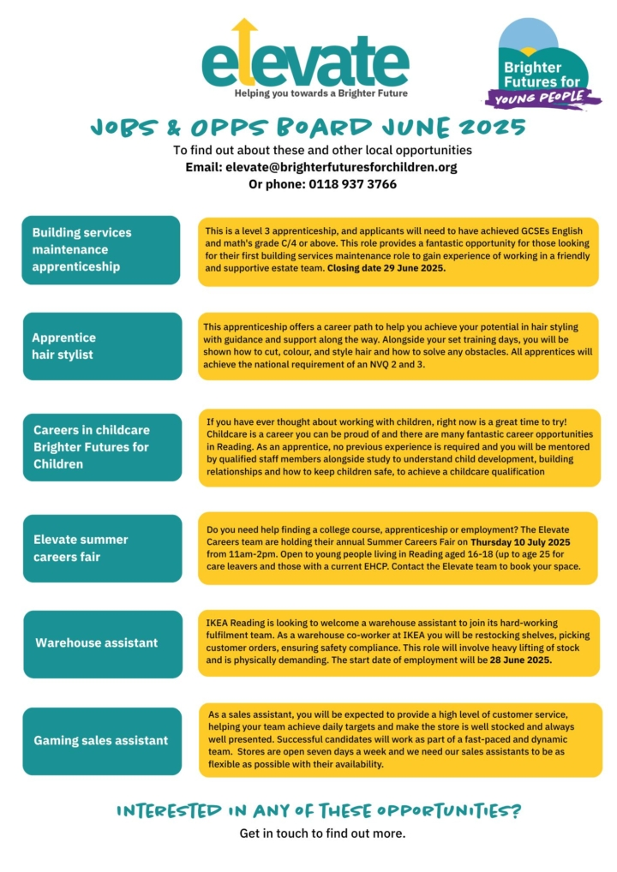

Click the image to open PDF view

Post-16 SEND opportunities
We can support you in your next steps.
We offer information, advice and guidance on post 16 education, employment and supported internships options.
If you want to find out more, email: elevate@brighterfuturesforchildren.org or phone 0118 937 3766.
Find out more about our providers of supported internships Ways Into Work, Shaw Trust and other SEND options on the Reading SEND Local employment page.

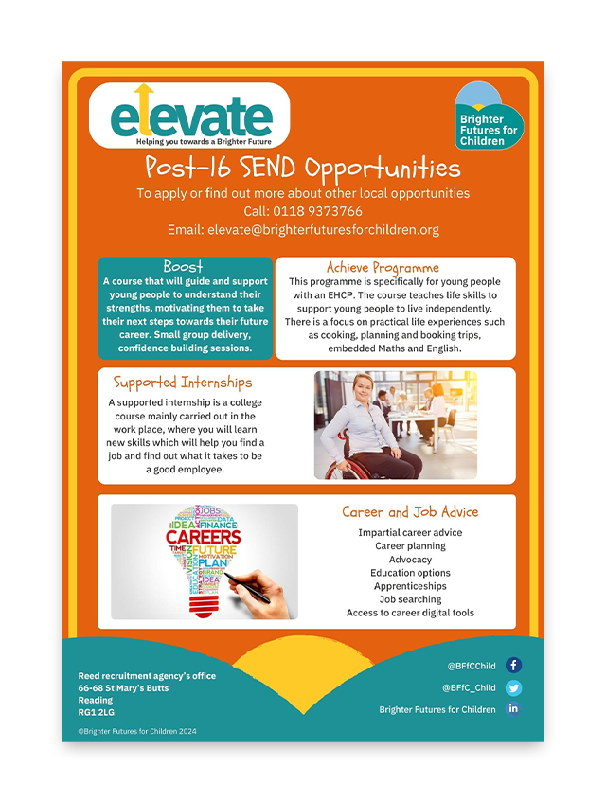



Reading Children's Business Fair
The Children’s Business Fair is a one-day marketplace where young entrepreneurs (aged 7-17 years) have the opportunity to launch a business, sell in an authentic setting and make their own money.
You can follow the Children’s Business Fair on Instagram, where there’s a video of the December fair held in Guildford:
@childrensbusinessfairuk
The promotional video below gives further insight into the event:
Children’s Business Fair Promo

Elevate partnership with Thames Water

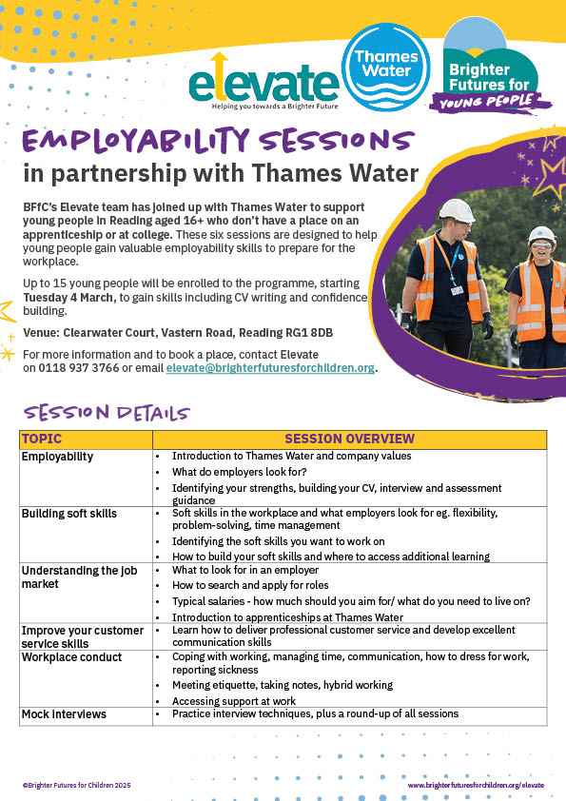

Elevate has teamed up with Thames Water to offer six sessions to young people in Reading who do not have a place on an apprenticeship or at college. These sessions are designed to build confidence and prepare for the workplace.
The next programme starts in March 2025.
For more information about this initiative contact the Elevate team elevate@brighterfuturesforchildren.org.


Exam results support
The team at Elevate careers service provides information, advice and guidance online, in person or by phone
Young people who are concerned about their exam results have a variety of ways to chat with the careers team about their possible next steps. They can:
- Book a face-to-face appointment in the Youth Hub based at: Reed Recruitment Agency, 66-68 St Mary’s Butts, RG1 2LG.
- Call: 0118 937 3766 or text: 07966 367499
- Email: elevate@brighterfuturesforchildren.org
The following websites offer advice for young people and parents/carers about coping with stress and anxiety around the exam results period:
- https://www.youngminds.org.uk/young-person/coping-with-life/exam-stress/#Dealingwithdisappointingexamresults
- https://www.youngminds.org.uk/young-person/blog/exam-results-stress-advice-for-young-people/
- https://www.childline.org.uk/get-involved/articles/coping-with-exam-results/

Our team
We are all professionally qualified career coaches, who are fully knowledgeable with local, regional and national careers information.

Romana Taylor
Team Manager

Claire Thomas
Careers Coach (Reading College NEET prevention lead)

Diane Teagle
Careers Coach (SEND Lead)

Saj Chowdhury
Careers Coach (Leaving Care and Youth Justice Service lead)

Nicky Ross
Data Performance Analyst

Contact us
Call: 07966 367499 or 0118 937 3766
Email: elevate@brighterfuturesforchildren.org

We look forward to speaking with you!
Brighter Futures for Children
Civic Offices
Bridge Street
Reading
RG1 2LU
0118 937 3641
info@brighterfuturesforchildren.org
Registration number 2502331
- Contact Us
- Cookie Policy
- Privacy Notice
- Modern Slavery Statement
- Family Information Service website
- Reading Borough Council website



