Spring Sensory Play/Exploration Ideas

Activity | What you’ll need | Learning/Play Opportunities
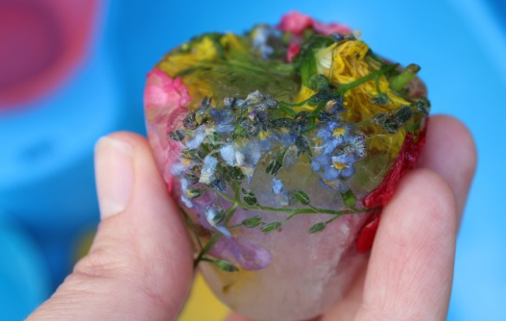  Frozen Flowers | - Flowers  - Herbs  - Water  - Small pots/trays  - A freezer! | - Encourage and support your child to experience and explore sensory play, so long as they are comfortable with this  - Look out for any reactions and responses during sensory play and treat these as communications  - Play/explore alongside your child, copying their actions, reactions and interactions  - What is your child responding to – the temperature? Textures? The smell? The colours? Focus on this element during play and use language that explains this and what they are doing  - Focus on and repeat up to five key words during an activity – e.g. flowers, cold, smell, yellow, blue, dig, pour, mix, splash etc. Or narrate what you and your child are doing as you play  - Support your child to play alongside/with you, another child, or a family member. Are they able to share resources and space, even if for a short time? Are they able to share attention on an activity with another person, even if for a short period of time?  - Can your child say/sign/ communicate any of the key words?  - Can your child extend their communication further e.g. requesting “more”, joining in with “ready, steady, go!”, naming colours, counting, “I see…”, “I smell….”, “I feel…”, “I hear…”  - Refer to the Motivate, Mirror, Model and Ready, Steady, Go information documents
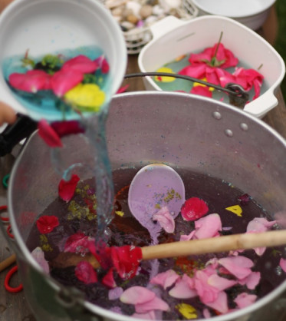  Spring Soup | - Tray or large pots  - Water  - Food colouring  - Flowers, leaves, petals  - Wooden spoons  - Ladles  - Small pots/bottles for filling and pouring  - Colanders/sieves
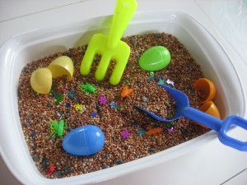  Spring Sensory Tub | - Bird seed  - Leaves  - Feathers  - Plastic eggs  - Plastic tools  or  - Soil  - Leaves  - Plastic insects  - Plastic tools
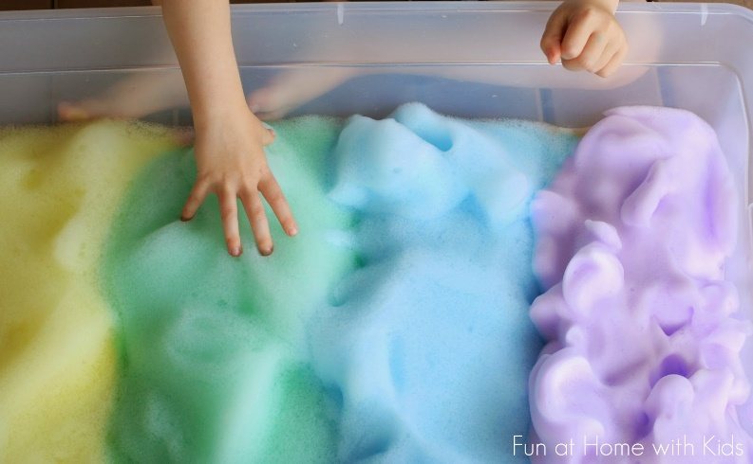  Rainbow Foam | - Bowls/trays  - Washing up liquid (2 tbsp per bowl)  - Water (100ml per bowl)  - Food colouring  - A mixer/whisk
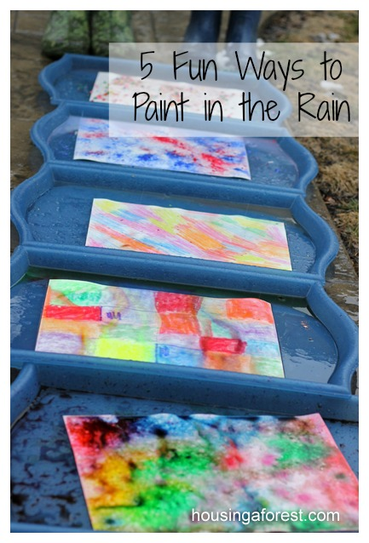  Rain Painting | - White paper in a tray  - Drops of food colouring, sprinkles of powder paint, scribbles using washable markers/ crayons, or broken watercolour paints on the paper  - Rain (or water from a watering can!)
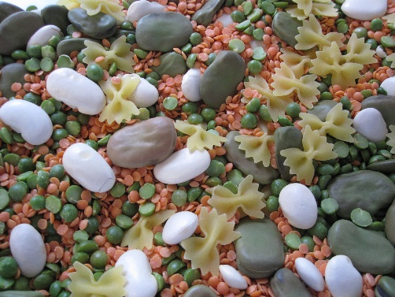  Spring Garden Sensory Tray | - Dried split peas  - Dried beans  - Dry lentils  - Dry pasta  - Seeds  - Soil  - Leaves  - Plastic tools and flower pots for digging and pouring
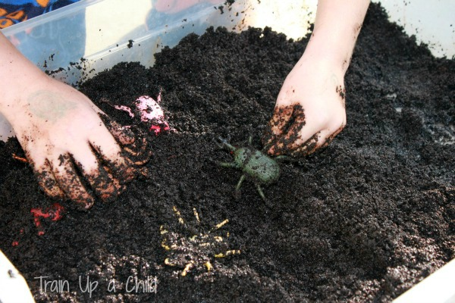  Insect Sensory Tray | - Damp coffee grounds  - Toy insects/bugs hidden in the coffee grounds
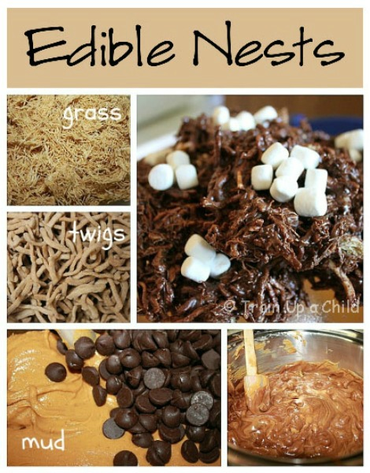  Edible Nests | - Shredded Wheat (grass)  - Bran (twigs)  - Peanut butter and chocolate chips (mud)  - Marshmallows (eggs)  Melt peanut butter and chocolate chips on low heat, stirring constantly (this could be done before your child joins in if safer). Once the ‘mud’ is melted and blended add the ‘twigs’ and ‘grass’. Line two cookie sheets with baking paper and form nests from the mixture. Refrigerate the nests until hardened. Once hard, add marshmallows on top.
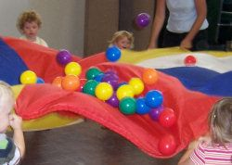  Spring Parachute Games | - Parachute or large sheet  - Balloons, flowers, petals, or leaves  Place the objects on top of the parachute and watch them move up and down. Try to keep them on the parachute/sheet!
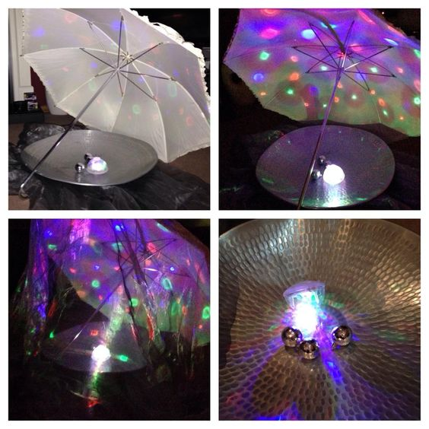  Spring Weather | - White umbrella or sheet (this could be placed hanging over the edge of a table or chairs)  - Metal dish/tin foil/mirror  - Lights  - Disco ball  You could also include ‘rain’ by spraying water, and ‘sunshine’ by shining yellow light and feeling heat packs/a hot water bottle
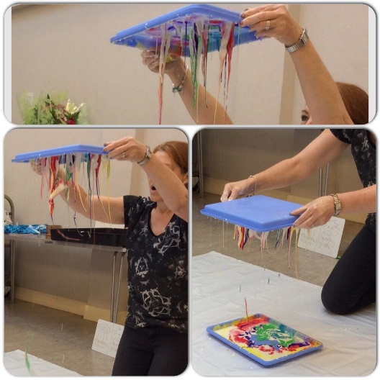  Colour Storm | - Two trays or one tray and a chopping board  - Corn Flour  - Water  - Colourful paints  Mix the corn flour with water in one tray, so that it becomes a consistency that feels solid when you first touch it, but then starts to ‘melt’. Add dots of colourful paint on top of the mixture. Place the second tray or the chopping board on top and press down, then slowly lift up
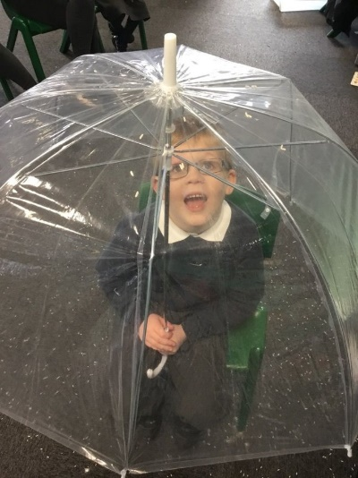  Raining on you | - Umbrella (preferably see-through, but any will do)  - Watering can (toy or real with sprinkle attachment)  - Water  One person sits holding the umbrella, the other slowly pours the water over the umbrella, so that it trickles down all around them.

