Art and Sensory Activity Ideas
Here are some (hopefully) easy to set-up, accessible art activities that I have collected that may suit our pupil’s different needs.

As some of us know, many of our pupils like to explore using taste. A child can get a lot of information and feedback about new or even familiar items or substances by putting them to their mouth, however this can make using things like paint quite difficult! I’ve included a recipe for making “edible” paints, which can be explored safely for our young people, and I will include a link I found in the email for a list of different recipes!
Puffy Paint Recipe
- 1 cup flour
- 1 cup salt
- 1/2-3/4 cup water
- Food colouring
Finger Paint Recipe
- Potato Flakes
- Food Colouring
- Hot water
Recipe for Chocolate Fizzing Slime
- 2 cups of cornstarch
- ¼ Cup of baking soda
- Cocoa mix
- 1 Cup of water
- ¼ cup of vinegar

Some of these activities can get quite messy. Allowing your child to explore a sensory tray or bowl helps them to develop awareness of their senses and can help to either alert or calm a child, depending on their preferences. Messy activities can also help a child access mark-making, whilst building on their fine-motor skills, using and strengthening the muscles in their hands and fingers, whether through mark-making in the ingredients or through use of tools (like spoons) to explore. I would recommend putting down newspaper, old towels or an old shower curtain on the floor to protect your carpets if you cannot carry these particular tasks outside!

Activity | Resources | What to do
Potato printing  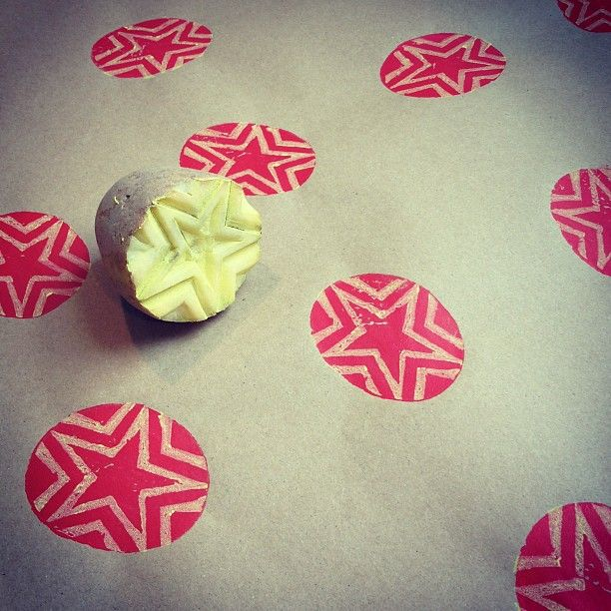 | Potato  Paint  Paper | Cut the potato in half (or into shapes such as stars!)  Dip the flat side into the paint, and then press onto the paper to mark-make.
Paint under cellophane  This is particularly good activity for a child to access mark-making who is sensitive to messy play.  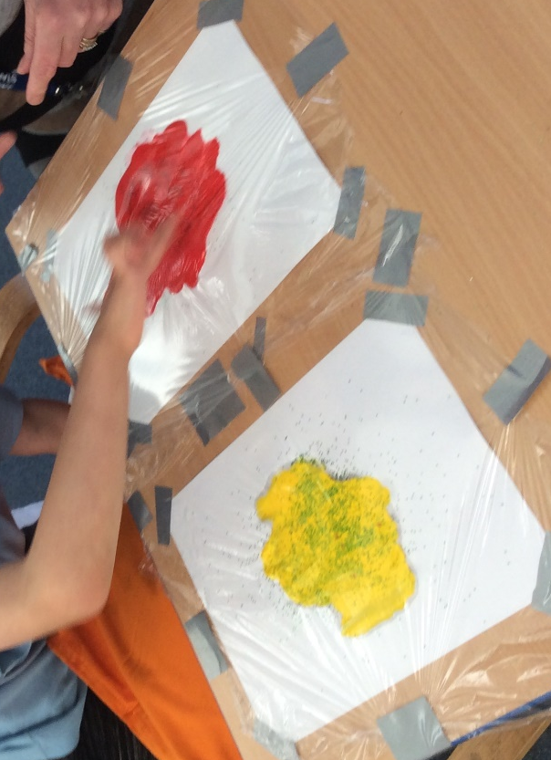 | Paper or tray  Paint  Cellophane  Cello tape | Fill a tray or some paper with thick paint  Place a sheet of cellophane over the paint, and tape down the edges.  For different textures, try putting pieces of dry rice or glitter into the paint, or mixing it with shaving foam!
Blowing Paint  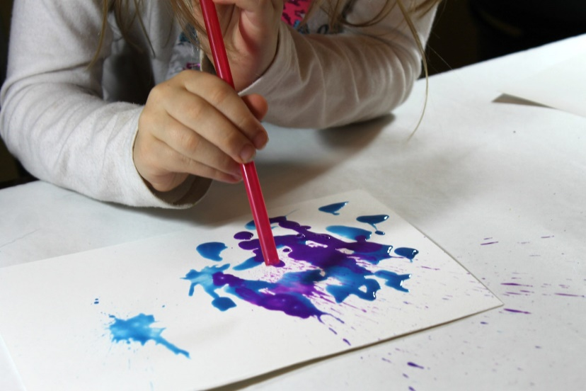 | Watered-down paint  Cups  Straws  Paper | Water down some paint in some cups.  Drop the paint onto the paper and then encourage pupil to blow the paint using straws.
Collaging  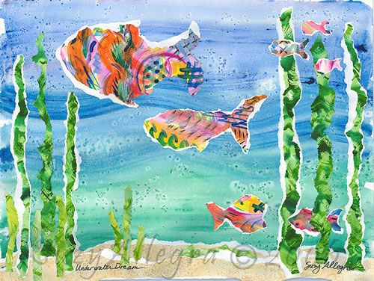 | Different coloured and/or textured paper or images  Glue  Glitter | Some of our pupils enjoy shredding or ripping paper, and enjoy gluing and sticking. Allow the pupil to rip different pieces of paper and arrange them however they like onto a piece of paper. You can give it a theme that interests your child by printing out a picture, for example an underwater theme, with pictures of fish to cut out or green paper to rip apart and make reeds.
Frozen Paint  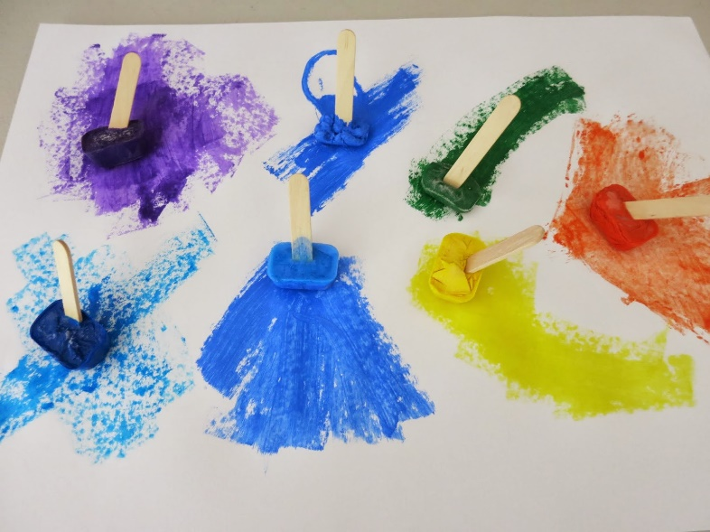 | Paint  Ice Cube Tray | Place the paint into an ice cube tray and put it in the freezer.  Once frozen, take it out and paint with it on the paper.
The following activities are more sensory based for pupils to explore:
Sensory Bag  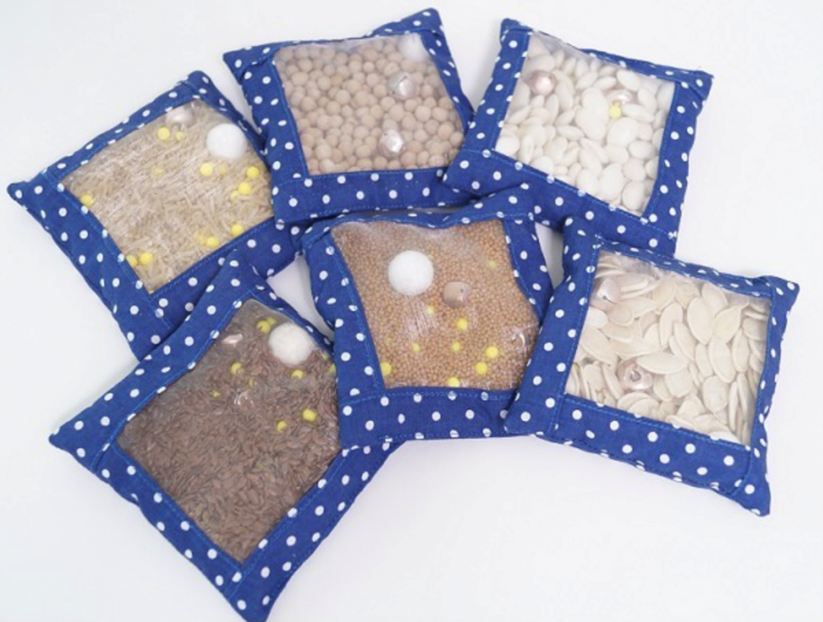 | Zip Bag  Herbs, Shaving Gel, Rice, flour. | Fill different zip bags with various textures, such as the ones listed.
Sensory Bottle  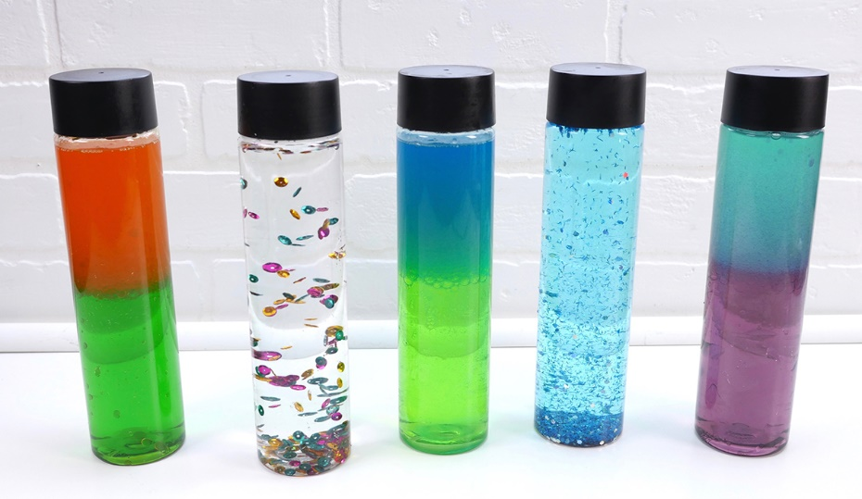 | Empty plastic bottle  Water  Food Colouring  Vegetable oil  Glitter | Fill the bottle to half way with water, and add a few drops of food colouring, then fill to the top with vegetable oil.  Tape the lid back on!
Messy Dry and Wet Trays  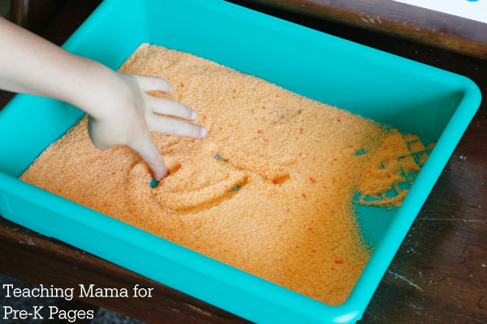 | Several trays or bowls | Fill two or more bowls or trays with messy foods, one wet and one dry.  This can be anything, such as flour and flour with water, porridge and porridge with water and honey. Allow the pupil to simply explore at their own leisure.
Whipped Cream + Popping Candy  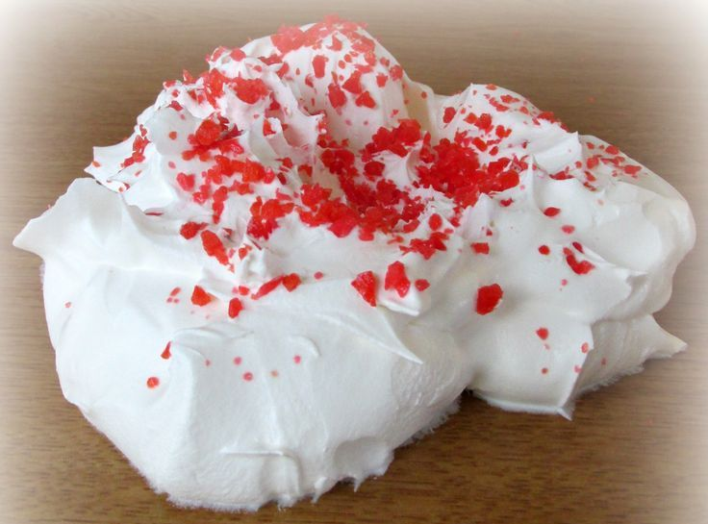 | Bowl or tray  Whipped Cream  Popping Candy | Mixing together whipped cream and popping candy into a sensory tray can be an exciting discovery for pupils that like to explore using their mouths.
Colourful Spaghetti  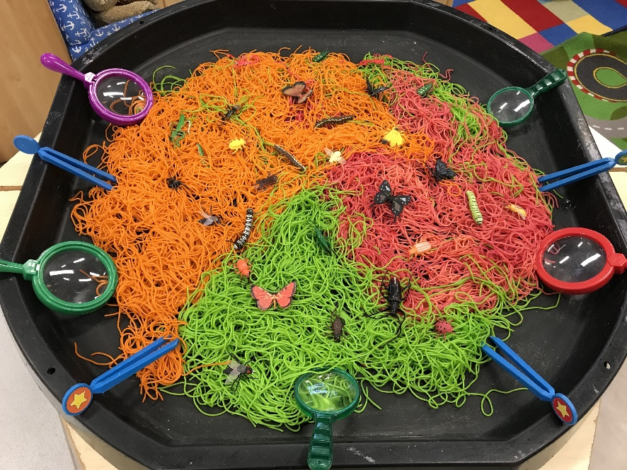 | Spaghetti or rice  Food Colouring  Scents (Optional) | Add food colouring to spaghetti or rice while cooking to make a more colourful exploration tray.

