Building on skills in Communication at home

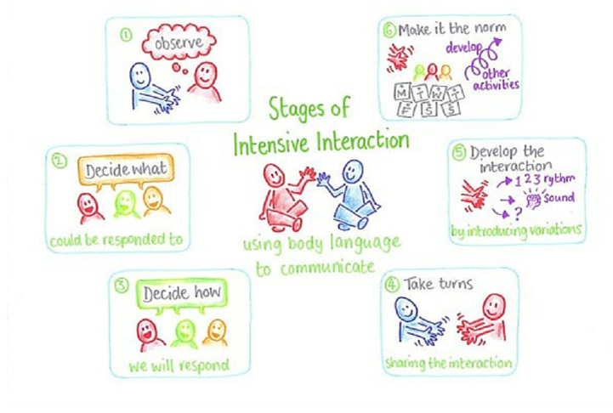
As parents, you have a unique and important role in building communication skills whilst your child is at home. You have already established strong relationships with your child, but through pre-verbal communication techniques such as Intensive Interaction and Floortime, you will be able to build on these relationships and use them to help your child practise key communication skills.
Intensive Interaction is a way of us changing our perception of communication and to prepare, we must:
Adjust our interpersonal behaviours – perhaps altering our voice, gaze or body language. This is to make us more interesting and inviting.
Take the child’s lead – respond to actions that your child does. This can be commenting on their actions, joining in with them, imitating them. By responding instead of leading, we don’t make demands on the child that they cannot cope with. Instead, we communicate that we value the child we are engaging with and we enjoy interacting with them.
Treat the things the child does as if they are acts of communication. We read social meaning into actions even when the meaning isn’t yet clear. In this way, the person is responded to as a communicator and gets to know what this feels like and to be involved. Plus, it’s essential to accept all forms communication unless the child or you as the adult are not safe.
Use sensitive observation to judge how well the interaction is going. As the communication partner, we respond quickly to any feedback, interpreting it so that we can keep the interaction positive and enjoyable for both partners. During intensive interaction we as the partner are seen to be a ‘guest’ in the child’s play. Therefore, it is important that when the child is communicating through verbal communication or through their behaviour that they have finished it is important that we respect their choice to finish.
Use timings and rhythm in interactions. This can make interactions like games – with anticipation and drama to hold the child’s attention. Rhythm and repetition help the child with learning disabilities to predict what will happen next and to get more involved. It can create the feeling of taking turns.

We are all capable of Intensive Interaction. When a parent is building their relationships with their newborn baby, you will usually find them mirroring the baby’s sounds, facial expressions, and using the baby’s own sounds to initiate or respond. It is applying these nurturing skills into a session accessible to our pupils. In addition, not only does Intensive Interaction support your child with building a positive relationship with you their parent but also teaches your child new skills which they can apply when building relationships with different people.

- Observe
Intensive Interaction is a way of allowing your child to invite you into their world. Whilst all of the pupils in Goldcrest have varying levels of communication and interaction, we can all begin at Stage 1, Observing. Spend some time with your child simply watching whatever they are doing without interruption. See what it is they are drawn to within your home, what they enjoy doing, what excites or calms them. Allow them to see that you are there, but not intervening or showing any judgement.

- Decide what can be responded to
There might be some things that your child is doing that you don’t want to present as positive behaviour, however during intensive interaction we focus on acceptance and allowing your child to feel as comfortable as possible. Try and decide which behaviours are okay, for example, some children like to make repetitive noises like clicking their tongue or humming, or some children like to play with objects or toys. These are usually considered acceptable behaviours, and are what you will perhaps want to focus on, without bringing attention to any unwanted behaviours.

- Decide how we will respond
The first steps to Intensive Interaction are simply mirroring and copying, whether it is through noises or movements. It might feel a little bit silly to begin with; getting down onto the floor and mirroring your child’s movements and sounds. However, over time, your child will begin to recognise what you are doing, and may begin to respond to you in turn. This is a huge skill necessary for building communication; finding someone to communicate to, and building a back and forth response.

- Take turns sharing the interaction
When your child begins to respond to you, you can begin to take turns in building a communication through sound or movement. Be patient, and always give your child lots of time to respond or initiate any kind of movement or sound within the session. Slowly, you may begin to see your child recognising that you are responding to their behaviours, and may feel encouraged to initiate more.

- Develop the interaction
Only when you are seeing consistent responses to your child, and they are initiating communication with you by waiting for responses, you can begin to develop on this interaction. For example, if the child is making sounds such as tapping on the floor, you can try and create a rhythm with your child and see if they are able to respond in turns. Tap twice on the floor, and see if your child will tap twice back – but keep it simple and easy to follow.

- Make it the norm
When you and your child are able to make strong, consistent initiation and responses in communicating through sounds and movement, you can begin to introduce these skills to everyday life. It is very important to pick up on all forms of communication, and Intensive Interaction focuses on us learning our pupil’s sounds, expressions and body gestures. You can begin to recognise these throughout the day and respond to them in positive and now familiar ways.

If you are interested in keeping a record of your child’s intensive interaction sessions to track progress, I have attached a copy of the NHS Intensive Interaction recording sheets.
If you would like to see examples of Intensive Interaction used with children with learning disabilities, there are plenty of good examples that can be found by searching “Intensive Interaction” or “Intensive Interaction early years” on YouTube.

