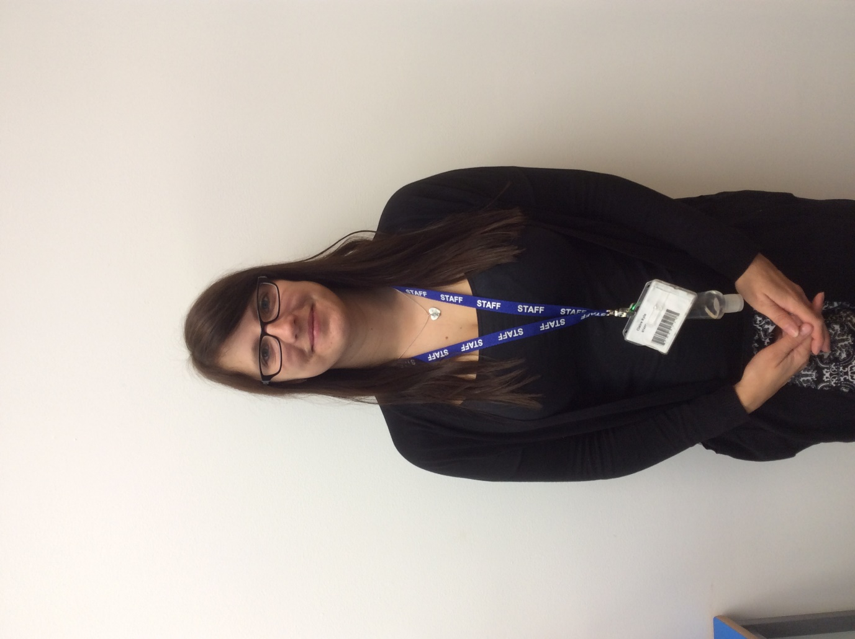

My name is Claire Kyle and I am your unison steward. I am based in Harrier Class. If you have any questions or would like to talk please email me on ckyle@avenue.reading.sch.uk.

