
A Ray of Soap!!


The Thoughtful Bubble Company provides meaningful work experience to Students at The Avenue Special Needs School
As part of our Careers and Work Related Learning plans 2019/2020 it had always been our intention to create an in house soap business. Although the national lockdown delayed our intentions it did give us the opportunity to research supporting organisations, which led us to the Peter Jones Foundation.
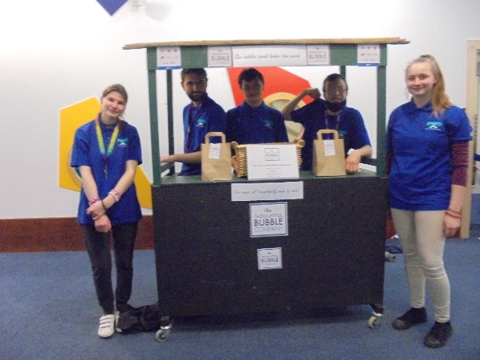
As part of the Peter Jones foundation, Tycoon Enterprise, The Avenue School loaned £254.00 risk free to create The Thoughtful Bubble Company. Our 6th form students have produced, wrapped, packed and sold 100’s of quality handmade soap bars. I think it is fair to say we could not keep up with production and overall we made 35KG of soap!!! This made the product more appealing and up until the last 20 bars we only sold via an ordering system. Vitally each student has gained experience of the work place in all aspects of production, quality control, fulfillment and customer service, during this first phase.
The Thoughtful Bubble Company took 3rd place in the National Tycoon Competition with sales of over £700.00!!!
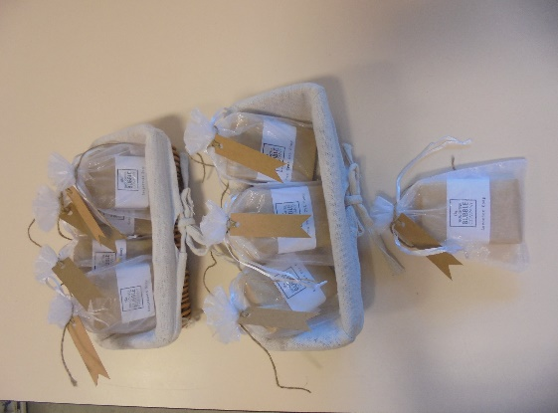
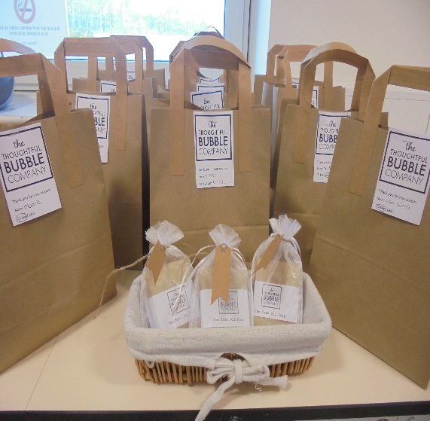
Our aim is to continue trading throughout 2021, with new and exciting products to be made & sold by students, at craft fayres, online and within our local community. Our profits will be reinvested into the further development of our brand, that will give the opportunity to many more students gaining the experience of the work place in a way that is accessible and meaningful.
Our short term plans are to expand into other products whilst keeping true to our brand (eco-friendly, natural products, vegan, recyclable packaging, made by students) our next products will be centred around Valentine and Mother’s day.
Our long-term aim is to register as a charitable business that offers supported volunteering & employment opportunities to SEND adults that have left full time education
The Tycoon Enterprise Competition is free, open to all schools, from Primary to sixth form, is fully resourced, with funding and learning resources provided.

