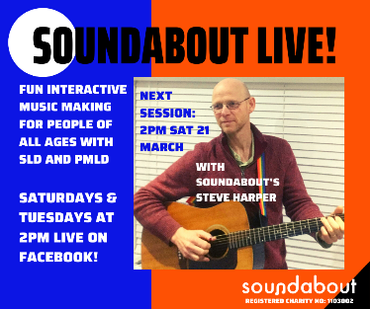
Soundabout are launching free Soundabout Live! interactive music-making sessions for people of all ages with severe learning difficulties and profound and multiple learning difficulties, starting on Saturday 21st March. Join them on Soundabout’s Facebook, website and YouTube channel at 2pm on Tuesdays and Saturdays for sessions led by specialist music practitioners. Bring a tambourine, shaker or some pots and pans to rattle and shake!
Chrome Music Lab is a website that makes learning music more accessible through fun, hands-on experiments. Have a play and see what kinds of sounds, rhythms and songs you can make:
https://musiclab.chromeexperiments.com/Experiments

Singing Hands have a selection of nursery rhymes and songs for you to sing and sign (Makaton) along to on their YouTube channel:
https://www.youtube.com/user/SingingHandsUK

