Avenue School Gatsby Benchmark Report 2019/2020
Background
This is the second year we have used the compass tool to measure our careers activity at the Avenue School. The compass tool is used widely across schools and colleges and enable us to monitor our success against the national average and the Thames Valley. In February 2020 the compass tool was adapted to capture data from special schools in a more meaningful way. As a school, we have completed the data pre-COVID 19 on 19th February 2020 and post- COVID 19 on 16th July 2020.
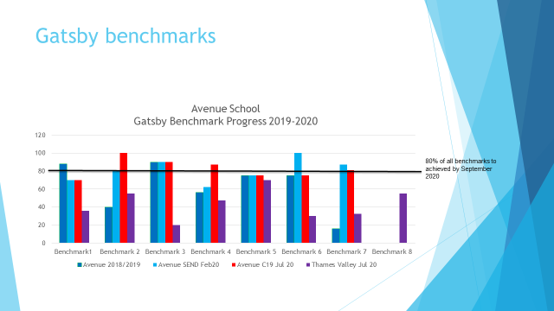
The Data in Figure 1 shows the Gatsby Benchmarks Progress for 2019-20 and compares progress pre COVID 19 and post COVID 19 for The Avenue School as well as with the Thames Valley.

Benchmark 1 - stable careers programme
All statutory guidance from the DfE is part of our day to day practice. To continue to improve in this area, and to further evaluate our programme, I will be seeking feedback from teachers, students and parents that will, in turn, create action points.

Benchmark 2 - learning from career and labour market Information
To strengthen this further, supporting transitions into the next setting regardless of pathway, we will be creating a central point of information for students and parents. This information will be used during career days, during parent’s evenings, annual reviews and recorded on Preparing for Adulthood Plans which are reviewed at least twice a year.

Benchmark 3 -addressing the needs of each learner
Career days are planned for the Life Skills and Independent Pathways. Students will be introduced to their own career journal and will become responsible for updating their progress and records.

Benchmark 4 - linking curriculum to learning in careers
Careers and enterprise are timetabled weekly with supported schemes of work purchased from Talentino.

Benchmark 5 - encounter with employers and employees
To fulfill this Benchmark, we need to think differently and will be focused on the opportunity COVID 19 has provided, for example starting our own business through enterprise.

Benchmark 6 – experiences of the work place
We will make up for lost ground following COVID 19 with the aim that all year 11,12,13 & 14 students gain experience of the work place linked to their preparing for adult plan. These could be either internal or external placements.

Benchmark 7 - encounter with further education
With the introduction of 6th form days for parents and students this will allow us to further communicate all the possible post 19 options for individual students and choices can be considered and agreed.

Benchmark 8 – personal guidance
To counteract the impact of COVID 19 and the missed opportunity of individual advice to all year 11 and 13 students, 2019/2020 students in years 11, 12, 13 &14 will be eligible during 2020/2021.

